Team 6D Newsletter - (May 18th – 21st) – Ms. Courville, Mrs. Sheets, Mrs. Medley, Mrs. Winans, and Mrs. Callegari

Mrs. Sheets’ Message:
FINAL WEEK – May 18 - May 21 SCIENCE ASSIGNMENT

We have reached the end of our school year ☹ I have enjoyed working with each of you this year in 6th grade science. I am missing you terribly and so sorry we didn’t have the chance to finish out this year as we all thought we would. I am confident that you will do well in 7th grade because I have seen what you can do when you try. Please join us on the last day of the school year for our last Zoom meeting this THURSDAY, May 21 at 1 p.m. I look forward to seeing you Thursday! Have a wonderful summer and drop by to say hello in August.
ZOOM MEETING
Thursday, May 21
1 p.m.
Meeting ID: 818 336 3734
Password: smms6D

Love you, Mrs. Sheets

1. Check your class period’s Google Classroom (see invitation in your school Gmail) for announcements and assignments

2. NEW - Go to https://nearpod.com/student/ and type the 5-letter code to complete the following lessons:
Distance in Space …………………. Code > WXCMR

3. NEW – Go to https://quizlet.com/_8ept8h?x=1qqt&i=162reb
Universe - 2020 Flashcards | Quizlet
quizlet.com
Start studying Universe - 2020. Learn vocabulary, terms, and more with flashcards, games, and other study tools.

to review
Universe 2020 - Flashcards

*** Make sure to type in your FIRST & LAST NAME when prompted to provide a name

Mrs. Callegari’s Message:
This is the last week of school, and I have to say this is breaking my heart not getting to say goodbye in person. If there are some assignments you have not completed, work on those this week please. To the students who have completed my assignments, you are finished and can start enjoying your summer for me today. I hope you all stay safe, keep learning over the summer, and remember I love you. You will always have a special place in my heart forever.

Love,
Mrs. Callegari

Mrs. Medley’s Message:
A from Mrs. Medley:

Assignments:
It’s Exam Week- Hard worker during this pandemic? You’re EXEMPT. 😊
Note:
It has been such a pleasure teaching you this year. I am very grateful that I had the chance to meet you and have you in my class. Homework- Have a fun & safe summer break. Next time I see you, you’ll be in 7th. 💞🥰
Javier- Found
Jackson- Travel Team
River- Crackback
Krista- Uglies
Matthew L.- Million Dollar Throw
Julian- The Big Time
Arianna- Summer Ball
Kaden B.- Football Champ
Cameron- Football Genius
Ben- Schooled
Farah- Gone
Lesly- Princess in Love
Kurbonnazar- The Big Field
Jesaira- Weekend
Stay well

Ms. Courville’s Message:
Ms. Courville ELA

1. Finish up any incomplete assignments

2. Have a wonderful and safe summer!

LAST Zoom meeting THURSDAY May 21 at 1:00
(This would have been the last day of school)

Meeting ID: 818 336 3734
Password: smms6D

Come join us to say goodbye for the summer!

Melissa Courville, NBCT
St. Martin Middle School

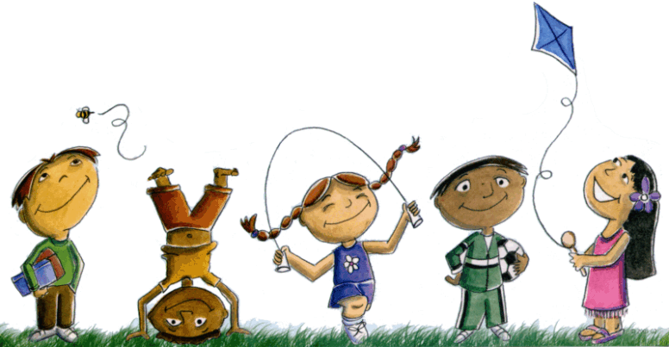

Mrs. Winans’ Message:
Please choose your favorite math game websites to wrap up our end of the year review. Be sure you choose games that work with 6th grade skills. Have a wonderful summer and stay safe! I will look for y’all in the hallways when you are back at school in 7th GRADE!!
Hope to see you at our Thursday Zoom!
Love, Mrs. Winans

